User Manual

1. Click on this link <https://github.com/hacker123shiva/BostonProject> to open the Web to predict the price of the House.
2. Startup page will display as below.

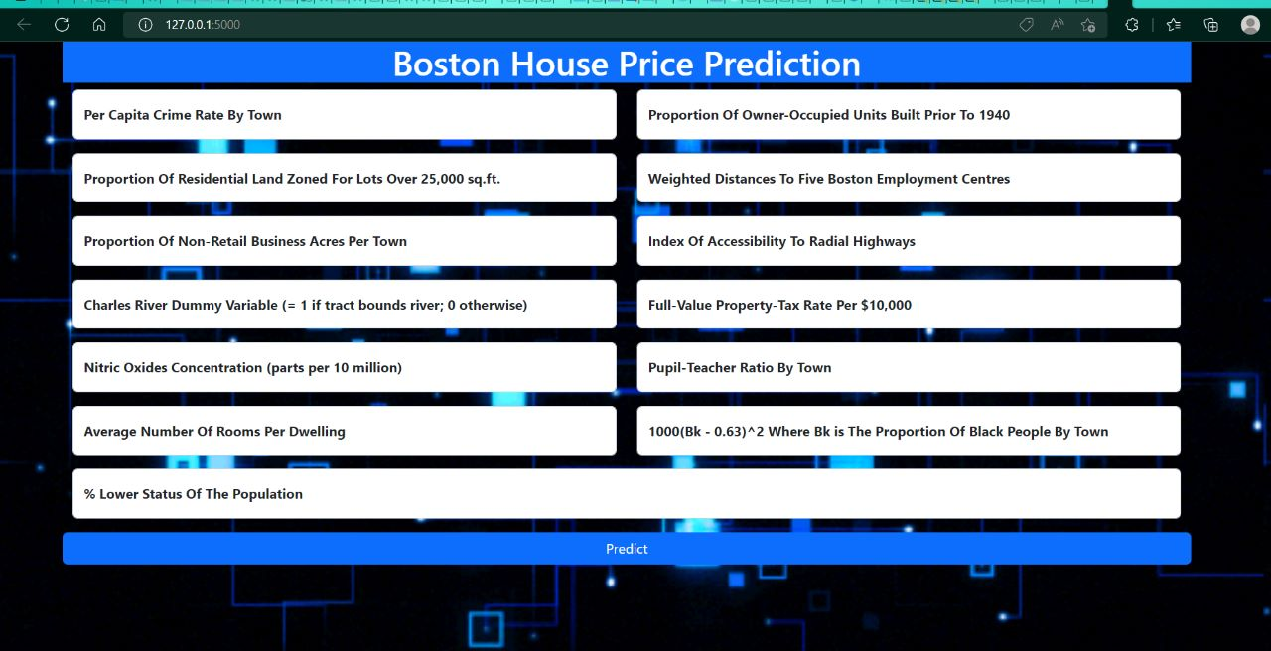

1. Enter a value for the prediction.

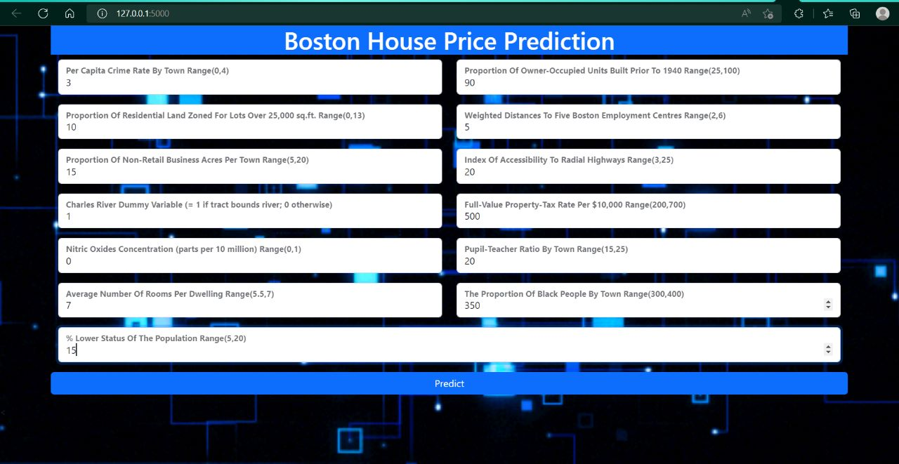

1. Press Prediction Button.

